1. A bank wants to understand the exact conditions under which loans are approved. Write a Python program implementing the FIND-S algorithm to learn the most specific hypothesis from positive loan approval examples and display the final hypothesis derived from the dataset.
AIM: FIND-S Algorithm to determine the most specific hypothesis
Procedure
- Initialize hypothesis with most specific values (Ø)
- Consider only positive examples
- Compare attributes and generalize if needed
- Ignore negative examples
- Output final hypothesis
Code:
# FIND-S Algorithm

data = [
['High','Good','Stable','Yes'],
['High','Excellent','Stable','Yes'],
['Medium','Good','Stable','Yes'],
['Low','Poor','Unstable','No']
]

# Initialize hypothesis
h = ['Ø','Ø','Ø']

for row in data:
if row[-1] == 'Yes':
for i in range(len(h)):
if h[i] == 'Ø':
h[i] = row[i]
elif h[i] != row[i]:
h[i] = '?'

print("Final Hypothesis:", h)
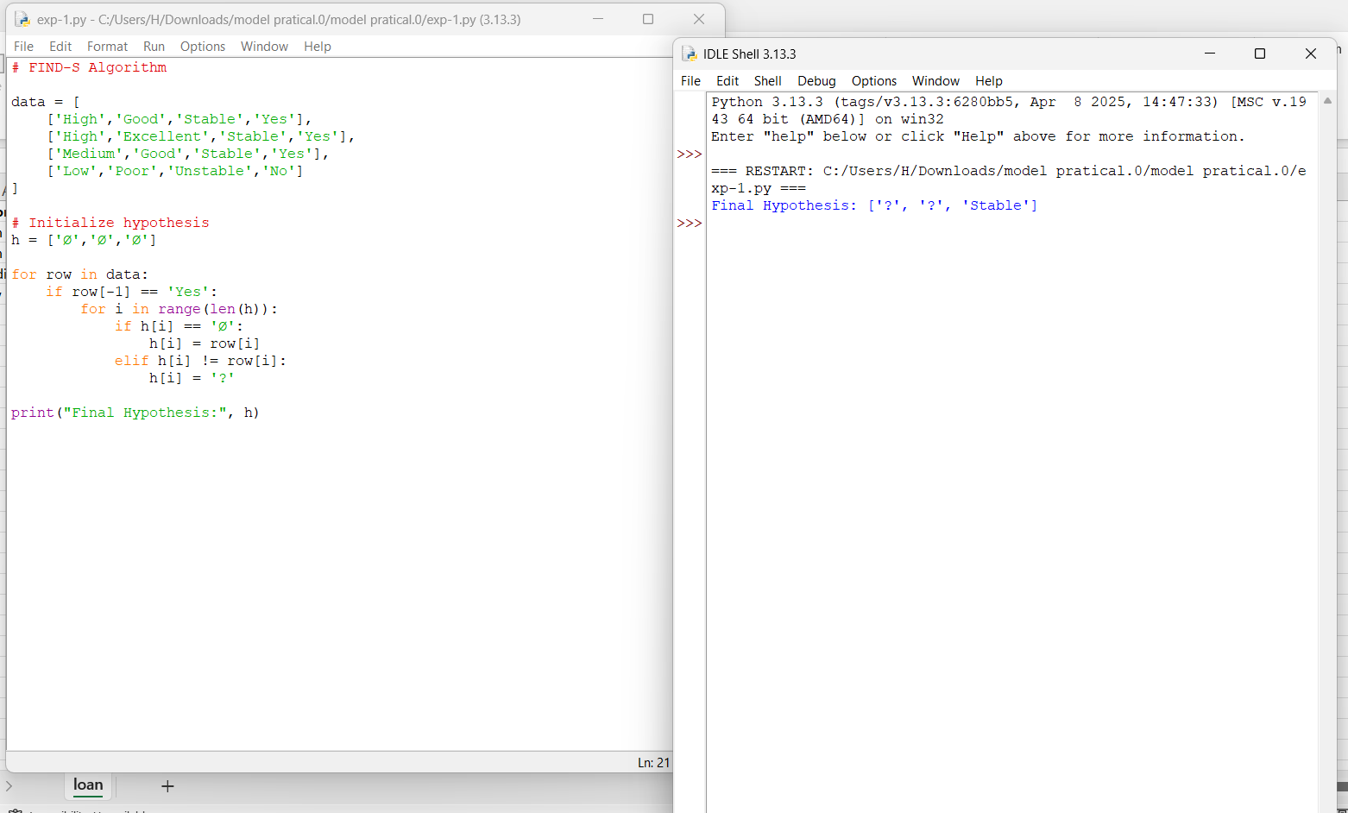
Output:

